Protecting the IC-703 from lightning, EMP and transient voltages. By – Frank KF2YD

Most ham gear does not have the proper protection against EMP, Lightning and Transient Voltages. Phil Salas – AD5X had a very good post about this subject which inspired me in making this new design. I decided to use the same transient voltage suppressor that Salas used but I have also included an EMP / lightning protection which I felt was much needed to protect ones radio from lightning, or EMP produced from an atomic explosion. I also decided that I wanted to mount all of the components inside my IC-703 so I wouldn’t have to make any splices to the radios power cable and to keep everything neat. The parts that will be required for this project consists of only 2 parts which are listed below. Total cost for the parts with shipping costs should cost you less than 10 dollars which I felt was very reasonable price to protect ones $700 investment.

1 Transient Voltage Suppresser 15V / 600W, Mouser P/N 511-P6KE15A $0.32
1 Bourns 2-Pole Gas Discharge Tube, Sparkover100V/s Mouser P/N 652-2027-09-B $1.96

The transient voltage suppressers anode is connected to one of the IC-703’s main board mounting screws that is located at the back right corner of the rig. The cathode side of the transient voltage suppresser is connected to the upper left side of the fuse holder. The Gas Discharge Tube is connected directly across the PL-259 connector located at the left corner of the main board of the IC-703.

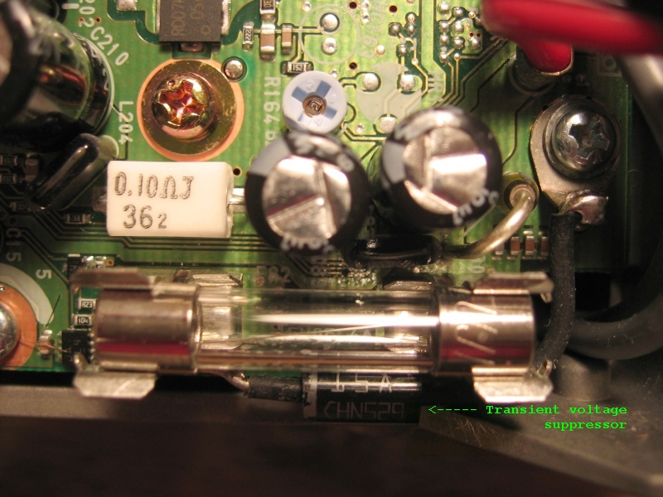

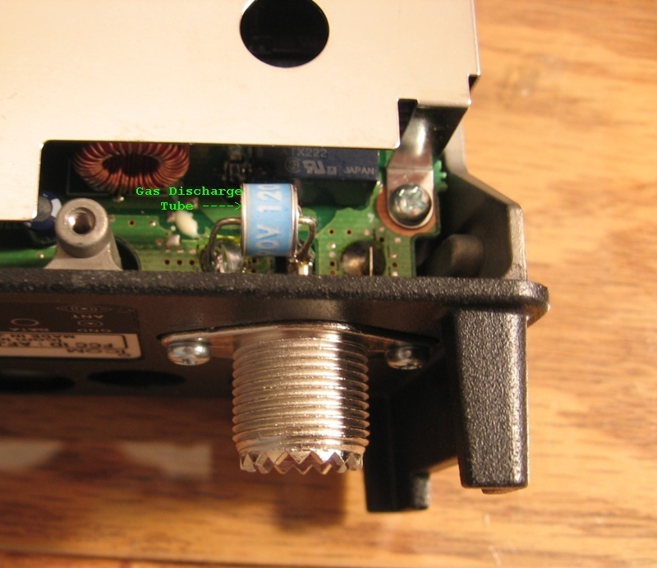

Notes: I recommend using shrink tubing on all the components. Make sure that all of the components used in this project do not come in close contact to any other nearby components.

